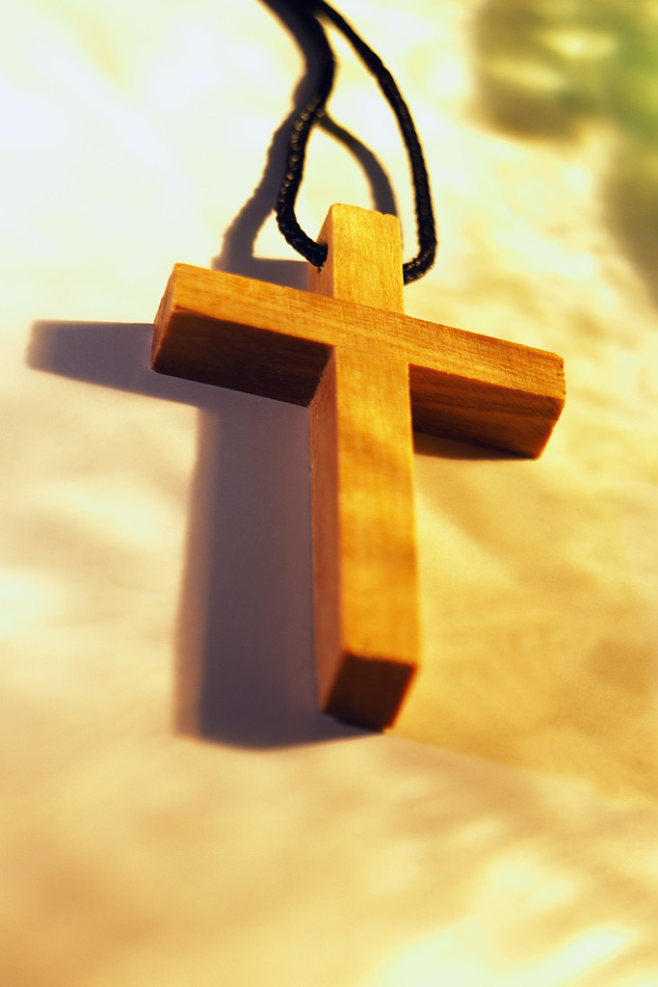 Prayer Service on Living an Ethical Style of Life

We commit ourselves to…
“Live an ethical style of life in which every choice we make is grounded in critical awareness of its impact on society and the planet.” (General Chapter Directives – 2009)

Song: (Your choice)

Reading: Maxim # 6 (Father John Pierre Medaille)
“Strip yourself entirely of the old self to clothe yourself with the new. According to this Maxim, lead a life dead to the world and to self-love, a life full of gentleness, humility of heart, sincerity, moderation, inward and outward peace, charity toward others; in a word, modeled on the holiness and virtue of Jesus whom you should form in yourself. Thus you may, by grace, attract many persons who will benefit from your example and company.”

Reflection: (Take one or two questions that speak to you)
- What does it mean to live an ethical style of life? What does it look like?
- When I reflect on the way I live, does my life speak to me, and to those who interact with me, of a life of gentleness, humility, sincerity, moderation and peace?
- Am I creating a space/atmosphere of non-violence by the way I speak?
- Is my response the same to the poor, as it is to the person who is well-fed and nicely dressed?
- Is my life style reflecting a reverence for all of God’s creation?
- Do I show respect for the earth and the natural resources of the earth?

Sharing your personal reflections

Personal and Communal Actions
- Is there one action I might consider doing as a result of my prayer and reflection?
- Is there one action we, as a Community, might consider doing as a result of our prayer and reflection?

Closing: Prayer (all recite)
Loving God, instill in my heart the desire to become that person you so want me to be. Amen!

Song: (Your choice )

